**Introduction**

FourICUPhysicians, Neurologists, and Surgeons were qualitatively interviewed at Dell Medical Center for expert clinical recommendations. The following questions were posed: (1) “How do you typically see delirium coded in electronic health records (EHR)?”; “What are some of the medical or other events that you see that causes you to make note that a patient may become delirious?” Shared sentiment concerning delirium coding in EHR was that a large portion of delirium cases are not explicitly coded as delirium due to compensation concerns at the hospital administration level. The practice is said to vary by organization/institution, but that it is ubiquitous. The experts indicated that common practice is to code diagnoses of various forms of altered mental state and non-specific encephalopathy. Shared sentiment concerning ‘red flags’ for delirium included persistent hypotension, shock, positive fluid balance, blood transfusions, and their pathway to the ICU – specifically being admitted having experience prior trauma.

The present analysis builds a random forest model using the MIMIC-III critical care database to classify ICU patients as having experienced a delirious episode or not using inputs that are informed by the literature and by clinical expertise. Our aim is the generate an algorithm that can inform patient care by serving as a reference for ICU physicians and nurses in which patients can be placed into bins and assigned a probability of having a delirious episode based on their current hospital admission records.

**Methods**

*Data* The MIMIC-III critical care database is a compilation of EHR consisting of over 50,000 hospital admissions to the intensive care units of Beth Israel Deaconess Medical Center in Boston, MA between 2001 and 2012. It contains extensive records, including bedside monitoring, charts, tests, orders, billing codes, demographics, and notes. The database is maintained and administered by Massachusetts Institute of Technology (MIT). Appropriate clearance to access the database was provided by MIT prior to the present study.

*Classification Variable*

56,475 hospital admits were mined for IDC-9 diagnostic codes indicative of Organic Psychosis / Delirium (limited to non-drug or alcohol induced), Non-organic psychosis (not otherwise specified), or Encephalopathy (not otherwise specified). 2,723 cases met these diagnostic criteria. 2,723 controls were defined as not being diagnosed with the above, randomly selected from the remaining 56,252 hospital admits.

*Input Variables*

Data was extracted to join cases and controls with their corresponding age, sex, ethnicity, which were dichotomized (<75=0, MALE=0, WHITE=0). 651,047 IDC-9 diagnoses were mined for pathology indicative of shock (3,916), current or history of traumatic brain injury (631), other traumatic injury (827), and fluid overload (357). 240,095 IDC-9 procedure records were mined for blood transfusion (10,827), hemodialysis (3,392), and resuscitation (647). 4,156,450 pharmaceutical instances were mined for the administration of loop diuretics (136,226) benzodiazepines (75,538), general anesthetics (37,715), antipsychotics (32,628), vasopressors (28,694), and barbiturates (326). Additional details for input variables are provided in Table 1 and Table 2. Cases and controls were joined with corresponding demographics, diagnostic, procedural, and pharmaceutical indices with binary classification of each input to form the final dataset.

*Data Munging*

Python Pandas was used for data extraction from the MIMIC-III database and for munging the final dataset. While joining patient data with input data, 278 patients were identified as having incomplete demographics, and 4,201 were identified as having missing pharmaceutical data. These patients were omitted. Remaining was 378 cases and 589 controls, leaving a final sample size of 967, with 16 input variables.

*Analysis*

The R package randomForrest was used to construct the model. All binary variables were set as factors. The model was specified as:

Delirium = Gender + Ethnicity + Over 75 + Antipsychotics + Barbiturates + Benzodiazepines + General Anesthetics + Loop Diuretics + Vasopressor + Shock + Fluid Overload + TBI + Trauma + Blood Transfusion + Dialysis + Resuscitation.

Model honing was performed visually by plotting OOB errors rates over 500 and then 100 trees and by optimizing the number of attempted variables at each split, with the initial model set at 4. Multidimensional scaling plots were used to visualize the model.

**Results**

The 500-tree random forest model with 4 attempts at each split had an OOB error rate of 38.68. The model accurately predicted delirium in patients 61.32% of the time. OOB error rates for model 1 are visualized in figure 1. The 1000-tree random forest model with 4 attempts at each split had an OOB error rate of 37.33, a marginal improvement considering the doubling in model size. The OOB error rates for model 2 are visualized in figure 2. No further increases in trees are necessary, and considering the marginal improvement, model 1 is more parsimonious. 1-10 variables were attempted at each split, and the default of 4 performed the best. A multidimensional scaling plot is presented in figure 3, which simulates Euclidian distance from different medical constellations, and how delirious and not delirious patients cluster around each. Visually, patients having been diagnosed with delirium seem to cluster closer to the medical constellations with non-delirium patients more apparent around the perimeter.

**Discussion**

The present analysis highlights the difficult in anticipating delirium. The selected model was accurate 61.32%, however it was biased towards classifying patients as non-delirious. A contingency table is presented in table 3. The model generated 40 false negative predictions, and 324 false-positives. It generated 54 true-positives and 549 true-negatives. Given the intended utility of this algorithm as a complementary technology to clinical intuition, false-positives are less determinantal than false-negatives. The result of a false-positive is that a patient received additional attention that is not needed. The result of a false-negative could divert attention away from a patient who needs it. Considering this, the ultimate utility of this technology is likely low. Further research is needed.

A severe limitation of the presented model should be noted. Of the original 5,446 patients identified for classification, over 80% were omitted due to missing data, the great majority of which was from the pharmaceutical records. This approach deserves further attention by identifying other variables within MIMIC, or perhaps proxy variables for the drugs investigated.

|  |  |  |
| --- | --- | --- |
|  | Indication | IDC-9 Code |
| *Diagnostic* | **Trauma:** |  |
|  | traumatic arthropathy | 71610, 71611, 71612, 71613, 71614, 71615, 71616, 71617, 71618, 71619 |
|  | traumatic pneumothorax/hemothorax | 8600, 8601, 8602, 8603, 8604, 8605, 85300 |
|  | amputation | 8850, 8851, 8860, 8861, 8870, 8871, 8872, 8873, 8874, 8875, 8876, 8877, 8960, 8961, 8962, 8963, 8970, 8971, 9872, 8973, 8974, 8975, 8976, 8977, 8950, 8951 |
|  | 80%+ body burn | 94881, 94882, 94883, 94884, 94885, 94886, 94887, 94888, 94889, 94890, 94891, 94892, 94893, 94894, 94895, 94896, 94897, 94898, 94899 |
|  | barotrauma | 9930, 9931 |
|  | traumatic compartment syndrome | 95891, 95892, 95893 |
|  | **Brain Injury:** |  |
|  | TBI | 85400, 85401, 85410 |
|  | Hx of TBI | 10087 |
|  | brain hematoma | 85220, 85221 |
|  | **Shock:** |  |
|  | Cardiogenic | 78551, 99801 |
|  | Septic | 78552, 99802 |
|  | Toxic | 4082 |
|  | Anestetic | 9954 |
|  | Traumatic | 9584, 9585 |
|  | **Positive Fluid Balance:** |  |
|  | Fluid overload | 27669 |
|  |  |  |
| *Procedural* | Resuscitation | 9393, 9960 |
|  | Blood transfusion | 752, 9900, 9901, 9902, 9903, 9904, 9905, 9906, 9907, 9908, 9909 |
|  | Hemodialysis | 3995, 5498 |

Table 1. Details of diagnostic and procedural input variables. Data were extracted from the DIAGNOSIS_ICD and PROCEDURES_ICD MIMIC files.

|  |  |  |
| --- | --- | --- |
|  | Drug Class / Proxy Indication | Generic Name |
| *Rx* | Benzodiazepines /  Sedation or Agitation or Seizure | 'Alprazolam', 'Clobazam', 'Clonazepam', 'Clorazepate', 'Chlordiazepoxide', 'Diazepam', 'Estazolam', 'Flurazepam', 'Lorazepam', 'Oxazepam', 'Quazepam','Temazepam', 'Triazolam' |
|  | General anesthetics / Sedation | 'Nitrous oxide', 'Sevoflurane', 'Halothane', 'Xenon', 'Enflurane', 'Chloroform', 'Isoflurane', 'Methoxyflurane', 'Desflurane', 'Ethyl chloride', 'Cyclopropane', 'Chloral hydrate', 'Ketamine', 'Esketamine', 'Etomidate', 'Propofol', 'Chlorobutanol' |
|  | Antipsychotics /  Psychosis or Mental Disturbance | 'Chlorpromazine', 'Droperidol', 'Fluphenazine', 'Haloperidol', 'Loxapine', 'Perphenazine', 'Pimozide', 'Prochlorperazine', 'Thiothixene', 'Thioridazine', 'Trifluoperazine', 'Aripiprazole', 'Asenapine', 'Clozapine', 'Iloperidone', 'Olanzapine', 'Paliperidone', 'Quetiapine', 'Risperidone', 'Ziprasidone' |
|  | Vasopressors / Hypotension | 'Phenylephrine', 'Norepinephrine', 'Epinephrine', 'Vasopressin', 'Dopamine', 'Isoproterenol', 'Dobutamine', 'Angiotensin II', 'Droxidopa' |
|  | Barbiturates / Sedation | 'Benzylbutylbarbiturate', 'butalbital', 'amobarbital', 'pentobarbital', 'secobarbital', 'Sodium thiopental', 'Phenobarbital' |
|  | Loop Diuretics /  Positive Fluid Balance | 'Furosemide', 'Bumetanide', 'Ethacrynic Acid', 'Torsemide' |

Table 2. Details of pharmaceutical input variables. Data were extracted from the PERSCRIPTIONS MIMIC file.

|  |  |  |
| --- | --- | --- |
|  | No | Yes |
| No | 549 | 40 |
| Yes | 324 | 54 |

Table 3. Contingency table for model 1 classifications.

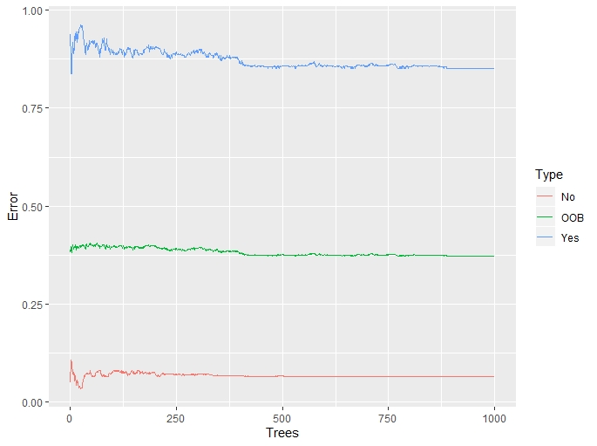

Figure 1. OOB Error plots for model 1.

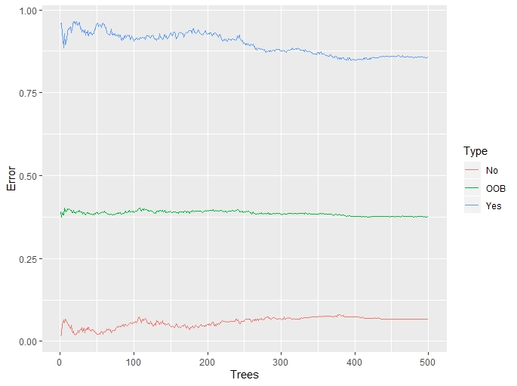

Figure 2. OOB Error plots for model 2.

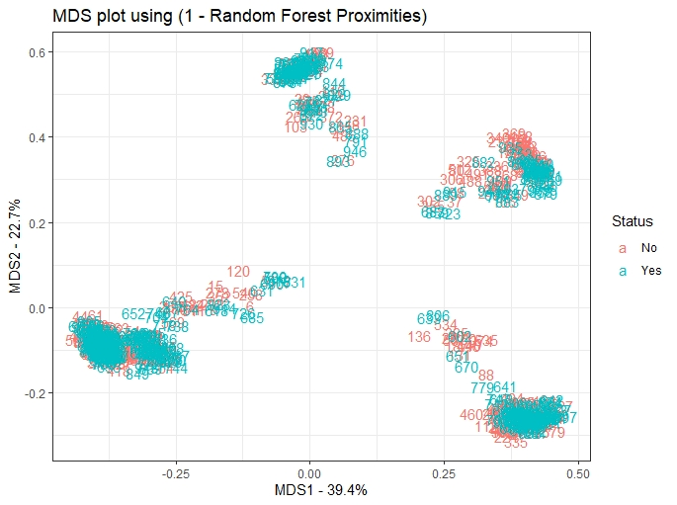

Figure 3. MDS Plot